**CHAPTER-3**

**SYSTEM REQUIREMENTS STUDY**

* 1. **USER CHARACTERISTICS**

The users are assumed to have basic knowledge to operate the system and must be familiar to work over the internet via web browser.

Users shall be familiar with document & multimedia files to interact with the system efficiently.

Users are supposed to know English language.

User should be able to do the following functions:

Create Account, Form, New job, Assets,

Access Job, Profile information, Documents

Update Job, Profile

Add attachments (image, audio, video,), Team members

Generate report

Close job, Reopen job

**3.1.1 Use Case Diagram:**

**1) Job Module**

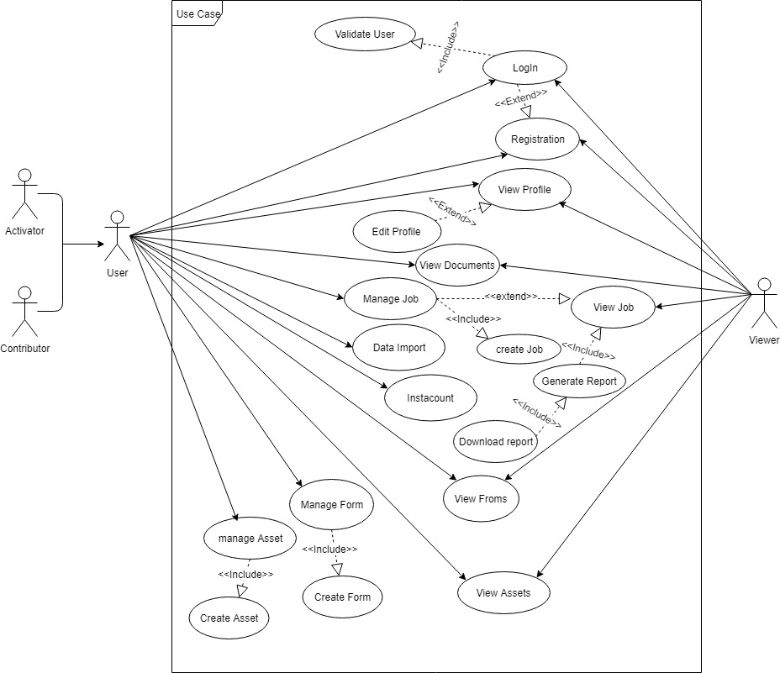

Fig: 3.1 Use Case Diagram (Job Module)

* 1. **HARDWARE AND SOFTWARE REQUIREMENTS**

**Hardware Requirements**

* **Developer Side:**
* Operating System: Windows XP , Vista
* Processor: 2.0 GHz or higher
* RAM: 4GB or more
* Hard Drive: 320 GB or more
* **Client side:**
* Any Mobile Device and Pc with internet connectivity

**Software Requirements**

* **Developer Side:**
* Visual studio/ Visual Studio Code
* **Client Side:**
* Web browser**.**
  1. **ASSUMPTIONS AND CONSTRAINTS**

**Assumptions:**

There are few assumptions for the system to run at its best based on how user interacts with the system like:

* The coding should be error free.
* The system should be user-friendly so that it is easy to use for the users
* The information of all the users must be stored in a safe place.
* Assume that admin have some technical background.
* Dashboard interface is available to users to get an overview.
* Login & registration modules are already created.
* Instacount, Forms & Assets modules are available to use in Job module.
* Administrator interface & functionalities are already created.

**Constraints:**

* User interface of Inspection and Evidence Control System should be easy to use.
* Commonly used links should be understandable.
* The phase of system analysis process deals with problems, which are affecting in the current manual system. The problems are those, which are affecting the organization in its daily routine work.
* As the growing trend in InfoTech World of computers need of accuracy, perfect, speed and high memory data storage is a must. Each and every problem must be solved with a least amount of time and energy.